**Java If-Else**

<https://www.hackerrank.com/challenges/java-if-else/problem>

In this challenge, we test your knowledge of using if-else conditional statements to automate decision-making processes. An if-else statement has the following logical flow:

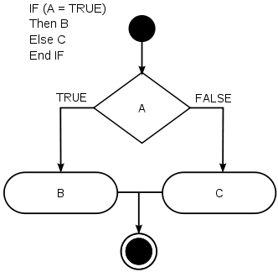

Source:[Wikipedia](https://en.wikipedia.org/wiki/Conditional_%28computer_programming%29)

**Task**  
Given an integer, n, perform the following conditional actions:

* If n is odd, print Weird
* If n is even and in the inclusive range of 2 to 5, print Not Weird
* If n is even and in the inclusive range of 6 to 20, print Weird
* If n is even and greater than 20, print Not Weird

Complete the stub code provided in your editor to print whether or not n is weird.

**Input Format**

A single line containing a positive integer, n.

**Constraints**

* 1 <= n <= 100

**Output Format**

Print Weird if the number is weird; otherwise, print Not Weird.

**Sample Input 0**

3

**Sample Output 0**

Weird

**Sample Input 1**

24

**Sample Output 1**

Not Weird

**Explanation**

Sample Case 0: n = 3  
n is odd and odd numbers are weird, so we print Weird.

Sample Case 1: n = 24  
n > 20 and n is even, so it isn't weird. Thus, we print Not Weird.